jQuery

Lab Book

Copyright © 2011 IGATE Corporation. All rights reserved. No part of this publication shall be reproduced in any way, including but not limited to photocopy, photographic, magnetic, or other record, without the prior written permission of IGATE Corporation.

IGATE Corporation considers information included in this document to be Confidential and Proprietary.

Document Revision History

|  |  |  |  |
| --- | --- | --- | --- |
| Date | Revision No. | Author | **Summary of Changes** |
| 05-Oct-2011 | 1.0 | Karthik M | Initial Draft |
|  |  |  |  |
|  |  |  |  |
|  |  |  |  |

Table of Contents

Document Revision History 2

Table of Contents 3

Getting Started 5

Overview 5

Setup Checklist for jQuery 5

Instructions 5

Learning More (Bibliography if applicable) 5

Lab 1. jQuery Basics 6

1.1: Creating jQuery Page 6

1.2: Accessing jQuery Script from CDN 8

Lab 2. jQuery Selectors 10

2.1: Selecting Nodes using tag name 10

2.2: Selecting Nodes by Element ID 12

2.3: Selecting Nodes by Class Name 13

2.4: Selecting Nodes by Attribute Value 15

2.5: Selecting Form Elements by type 16

TODO Assignments 18

Lab 3. Working with JSON 20

3.1: Working with JSON Object 20

3.2: Working with JSON Object and Array 21

3.3: Using JSON object in jQuery 22

Lab 4. Interacting with DOM 24

4.1: Iterate Nodes using jQuery 24

4.2: Sort list items using jQuery 25

Stretched Assignments 27

TODO Assignments 28

Lab 5. Handling Events & Animations in jQuery 29

5.1: Adding and Removing Style at runtime using Click Event 29

5.2: Preventing Cut-Copy-Paste in textbox 30

5.3: Identifying mouse button 31

5.4: Limiting number of characters in textarea 33

5.5: Check/Uncheck all checkboxes at once 34

5.6: Event Triggering 36

5.7: Animating List as tree view 37

TODO Assignments 38

Lab 6. Working with Ajax 39

6.1: Using jQuery load() function 39

6.2: Using jQuery post() function 41

6.3: Using jQuery ajax() function 42

6.4: Insert record using RESTful Service(POST verb) 44

6.5: Retrieve record(s) using RESTful Service (GET verb) 46

6.5: Delete record using RESTful Service (DELETE verb) 47

Lab 7. Working with Plug-ins 50

7.1: Using jQuery-UI 50

TODO Assignments 53

7.2: Creating Function Plugin 54

7.2: Creating Method Plugin 55

7.3: Creating Method Plugin(Form Validation) 57

<<Streched Assignment>> 59

Appendices 60

Appendix A: Coding Best Practices 60

Appendix B: Table of Figures 63

Getting Started

## Overview

This lab book is a guided tour for learning jQuery. It comprises solved examples and ‘To Do’ assignments. Follow the steps provided in the solved examples and work out the ‘To Do’ assignments given.

## Setup Checklist for jQuery

Here is what is expected on your machine in order for the lab to work.

Minimum System Requirements

* Intel Pentium 90 or higher (P166 recommended)
* Microsoft Windows XP or above.
* Memory: 256MB of RAM (512MB or more recommended)
* Internet Explorer 6.0 or higher

Please ensure that the following is done:

* A text editor like Notepad, Editplus

## Instructions

* For all coding standards refer Appendix A. All lab assignments should refer coding standards.
* Create a directory by your name in drive <drive>. In this directory, create a subdirectory jQuery_assign. For each lab exercise create a directory as lab <lab number>.
* You may also look up the on-line help provided in the <http://www.jquery.com>.
* The faculty will introduce you to the editor to be used.

## Learning More (Bibliography if applicable)

* Visual QuickStart Guide jQuery by Steven Holzner
* jQuery in Action by Bear Bibeault and Yehuda Katz
* Learning jQuery 1.3 by Jonathan Chaffer and Karl Swedberg

1. jQuery Basics

|  |  |
| --- | --- |
| **Goals** | * Understand the process of creating a jQuery page and viewing it in a browser window. * Understanding Content Delivery Network (CDN) and using the hosted jQuery file from Google or Microsoft |
| **Time** | 20 minutes |

## 1.1: Creating jQuery Page

Create a web page to display the message box ‘Hello World’.

Solution:

**Step 1:** Download the latest java script file (jquery-1.6.4.min.js) minified version from <http://www.jquery.com>

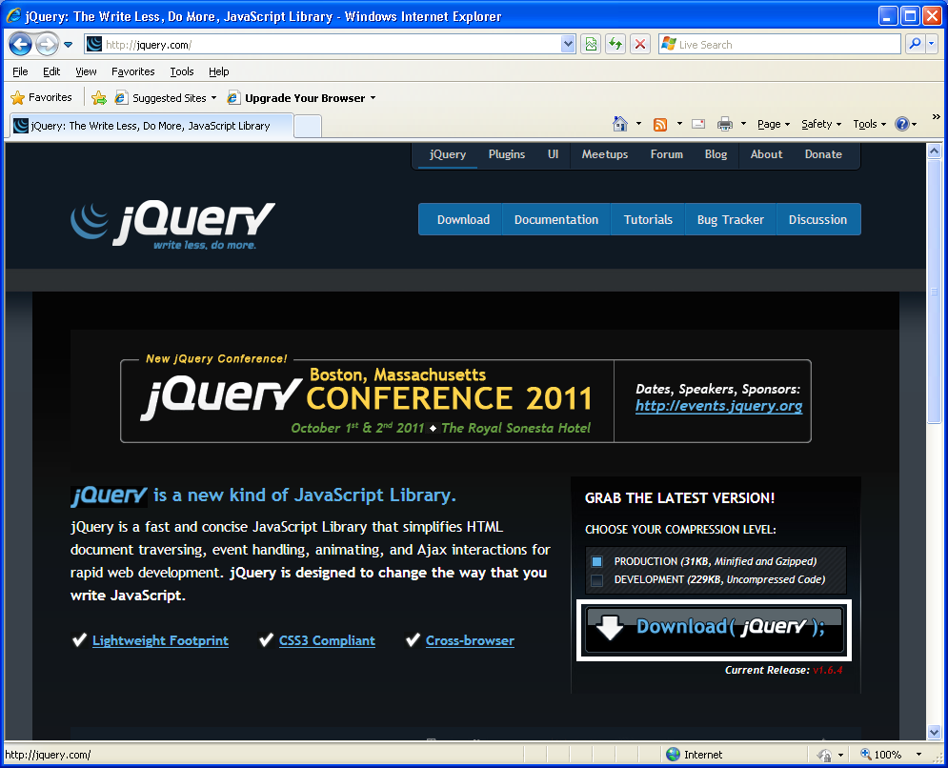

Figure 1: jquery.com

**Step 2:** Create a folder named scripts under jQueryDemos in C:\ or D:\ and place the downloaded script there.

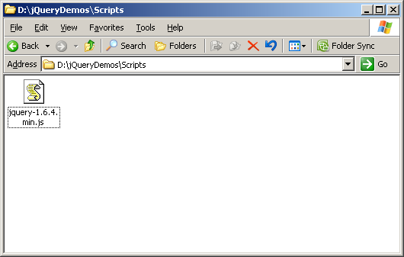

Figure 2: jQuery Folder Structure

**Step 3:** Open any text editor like notepad and type the following code and save it with .html extension in jQueryDemos folder.

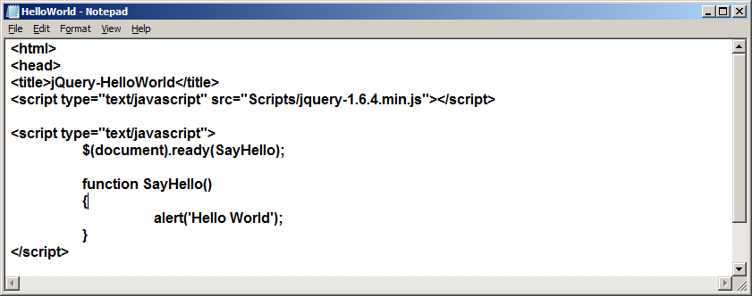

Figure 3: Save contents as an *.html* file

**Step 4:** Open the file which we have saved, in browser. Output will appear as shown in the following figure:

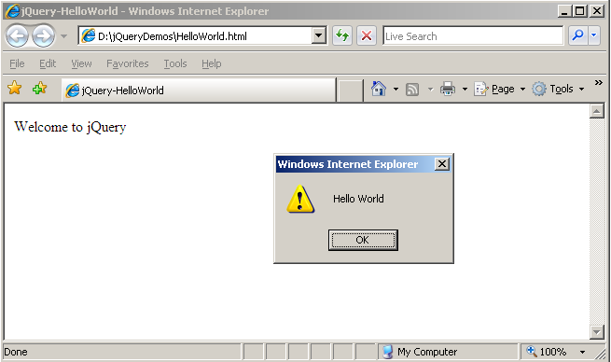

Figure 4: HelloWorld.html in a browser

## 1.2: Accessing jQuery Script from CDN

Create a jQuery web page and access the jQuery script from Google

Solution:

**Step 1:** Open any text editor like notepad and type the following code and save it with .html extension in jQueryDemos folder

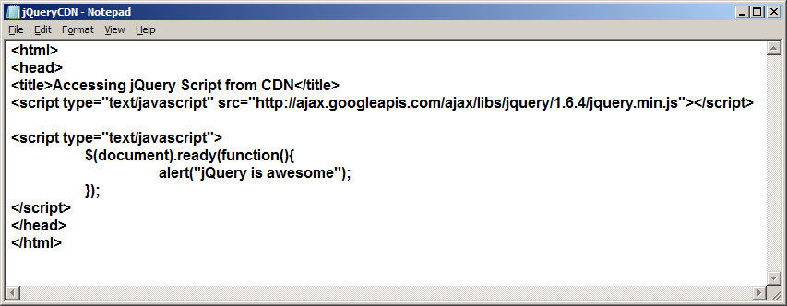

Figure 5 Accessing Script from CDN

**Step 2:** Output will appear as shown in the following figure:

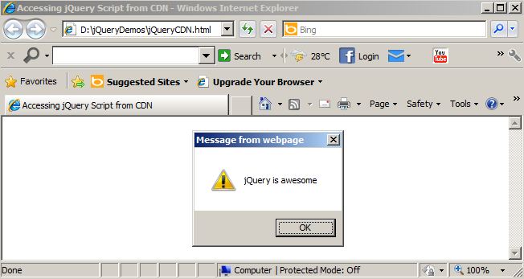

Figure 6 jQueryCDN.html in browser

 Script can be also accessible from

Microsoft jquery Script: <http://ajax.aspnetcdn.com/ajax/jQuery/jquery-1.6.4.min.js>

jQuery Domain : <http://code.jquery.com/jquery-1.6.4.min.js>

1. jQuery Selectors

|  |  |
| --- | --- |
| **Goals** | * At the end of this lab session, you will be able to perform the following topics using jQuery Selectors: * Selecting nodes using Tag Name * Selecting Nodes by ID * Selecting Nodes by Class Name * Selecting Nodes by Attribute Value * Selecting Input Nodes |
| **Time** | 60 minutes |

## 2.1: Selecting Nodes using tag name

Create a jQuery web page and select all the paragraphs apply blue background and white foreground to it. Select the paragraphs under div tag and change the text in that paragraph to uppercase. Navigate though all the paragraphs and print the contents within it in a message box

Solution:

**Step 1:** Open any text editor like notepad and type the following code and save it with .html extension in jQueryDemos folder

<html>

<head>

<title>Selectors By Tag Name</title>

<script type="text/javascript" src="Scripts/jquery-1.6.4.min.js"></script>

<script type="text/javascript">

$(document).ready(function()

{

//Selecting all the paragraphs

var paragraphs = $('p');

//Applying Styles to all the paragraphs

paragraphs.css('background-color','blue');

paragraphs.css('color','white');

//Applying Styles to the paragraphs under div tag (descendants)

var divParagraphs= $('div p');

divParagraphs.css('text-transform','uppercase');

//Navigating though all paragraph tags and print the contents within it using //message box

var collection = $('div,p');

paragraphs.each(function(){

alert($(this).html());

});

});

</script>

</head>

<body>

<p>First Paragraph</p>

<p>Second Paragraph</p>

<div>

<p>First Paragraph - inside div tag </p>

<p>Second Paragraph - inside div tag </p>

</div>

</body>

</html>

**Step 2:** Output will appear as shown in the following figure

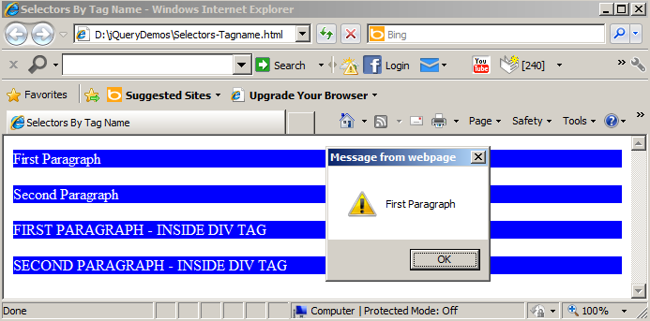

Figure 7 Selectors-TagName.html in browser

## 2.2: Selecting Nodes by Element ID

Create a jQuery web page to retrieve the contents from one div tag in html format and apply the retrieved content into another div tag in text format

Solution:

**Step 1:** Open any text editor like notepad and type the following code and save it with .html extension in jQueryDemos folder

<html>

<head>

<title>Selectors By ElementID</title>

<script type="text/javascript" src="Scripts/jquery-1.6.4.min.js"></script>

<script type="text/javascript">

$(document).ready(function()

{

//Retrieving the content from testDiv in html format

var data = $('#testDiv').html();

//Applying the content to targetDiv in text format

$('#targetDiv').text(data);

});

</script>

</head>

<body>

<div id="testDiv">

<b>This is my Test Div text</b>

</div>

<div id="targetDiv" />

</body>

</html>

**Step 2:** Output will appear as shown in the following figure

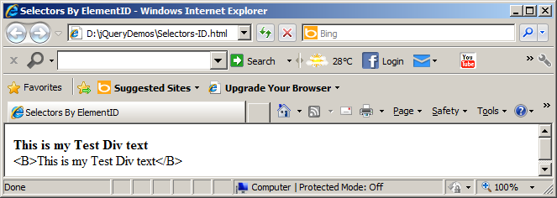

Figure 8 Selectors-ID.html in browser

## 2.3: Selecting Nodes by Class Name

Create a jQuery web page to apply styles to the elements that don’t match a specific selector

Solution:

**Step 1:** Open any text editor like notepad and type the following code and save it with .html extension

<html>

<head>

<title>Selectors using class Name</title>

<style type="text/css">

.blueDiv{background-color:blue; color:white;}

.redDiv{background-color:red; color:white;}

</style>

<script type="text/javascript" src="Scripts/jquery-1.6.4.min.js"></script>

<script type="text/javascript">

$(function ( ) {

//Selects divs that do not have the class 'redDiv' using not filter

var collection = $('div:not(.redDiv)');

collection.css('border','5px solid green');

collection.css('padding','5px');

});

</script>

</head>

<body>

<div class="blueDiv">

<p>First BlueDiv - Paragraph.</p>

</div>

<div class="redDiv">

<p>First RedDiv - Paragraph.</p>

</div>

<div class="blueDiv">

<p>Second BlueDiv - Paragraph.</p>

</div>

</body>

</html>

**Step 2:** Output will appear as shown in the following figure

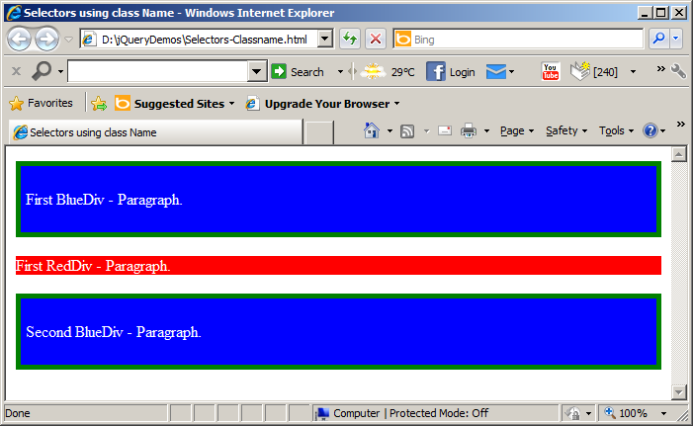

Figure 9 Selectors-Classname.html in browser

## 2.4: Selecting Nodes by Attribute Value

Create a jQuery web page to select elements based on attributes (input) and attributes values (text) and apply styles to it.

**Solution:**

**Step 1:** Open any text editor like notepad and type the following code and save it with .html extension

<html>

<head>

<title>Selectors By Attributes</title>

<style type="text/css">

.applyStyles {color:white;background-color:black;text-transform:uppercase;}

</style>

<script type="text/javascript" src="Scripts/jquery-1.6.4.min.js"></script>

<script type="text/javascript">

$(function ( ) {

var textBoxes = $('input[type="text"]');

textBoxes.addClass("applyStyles");

});

</script>

</head>

<body>

<table> <tr>

<td align="right"><span>Name : </span></td>

<td><input type="text"/></td> </tr>

<tr>

<td align="right"><span>City : </span></td>

<td><input type="text"/></td> </tr>

</body> </html>

**Step 2:** Output will appear as shown in the following figure

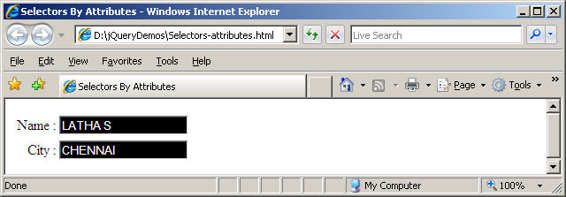

Figure 10 Selectors-attributes.html in browser

## 2.5: Selecting Form Elements by type

Create a jQuery web page to select the checked radio button and display its index position and value

**Solution:**

**Step 1:** Open any text editor like notepad and type the following code and save it with .html extension

<html>

<head>

<title>Input Selectors</title>

<script type="text/javascript" src="Scripts/jquery-1.6.4.min.js"></script>

<script type="text/javascript">

$(document).ready(function()

{

var $radChecked = $(':radio:checked');

$("#targetDiv").text('')

.append("<b>Index: </b>" +$radChecked.index() + "<br/>")

.append("<b>Value: </b>" +$radChecked.val());

});

</script>

</head>

<body>

<table>

<tr>

<td>

<input type="radio" name="gender" value="Male">Male

<input type="radio" name="gender" value="Female" checked="checked">Female

</td>

</tr>

<tr>

<td>

<div id="targetDiv" />

</td>

</tr>

</table>

</body>

</html>

**Step 2:** Output will appear as shown in the following figure

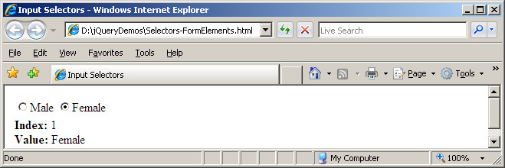

Figure 11 Selectors-FormElements.html in browser



:text selects <input type="text" />

:password selects <input type="password" />

:radio selects <input type="radio" />

:checkbox selects <input type="checkbox" />

:submit selects <input type="submit" />

:image selects <input type="image" />

:reset selects <input type="reset" />

:button selects <input type="button" />

:file select <input type="file" />

:hidden selects <input type="hidden" />

:input filter selects all input, textarea, button, and select elements.

## TODO Assignments

Assignment-1: Use the following html code snippet

<table id="region" border="2" bordercolor="black">

<thead>

<tr>

<th>State</th>

<th>Capital</th>

</tr>

</thead>

<tbody>

<tr>

<td>Andhrapradesh</td>

<td>Hyderabad</td>

</tr>

<tr>

<td>Karnataka</td>

<td>Bangalore</td>

</tr>

<tr>

<td>Maharashtra</td>

<td>Mumbai</td>

</tr>

<tr>

<td>Tamilnadu</td>

<td>Chennai</td>

</tr>

</tbody>

</table>

<div id="StatesDiv"></div>

<div id="CapitalDiv"></div>

* Retrieve the states from the table and print the states in ordered list
* Retrieve the 4th State’s Capital and print it

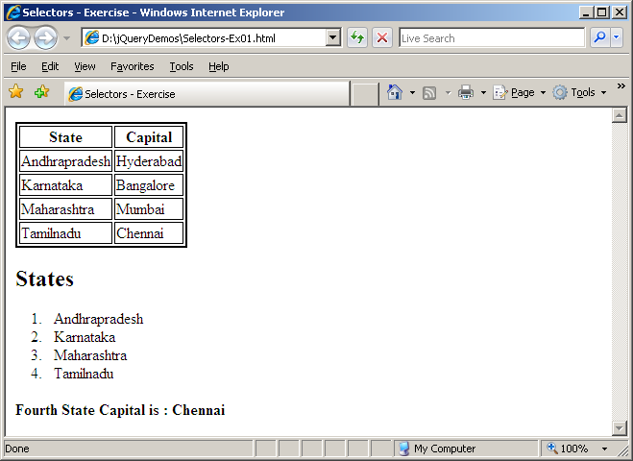

Figure 12 Assignment output

1. Working with JSON

|  |  |
| --- | --- |
| **Goals** | * At the end of this lab session, you will be able to * Work with JSON Object * Using JSON in jQuery |
| **Time** | 20 minutes |

## 3.1: Working with JSON Object

Create a webpage to store the employee details as JSON Object and retrieve the employee details and print it

Solution:

**Step 1:** Open any text editor like notepad and type the following code and save it with .html extension

**Step 2:** Output will appear as shown in the following figure

<html>

<head>

<title>JSON Introduction</title>

<script type="text/javascript">

var jsonObject = {"EmployeeID":714709, "Name":"Karthik M", "Department":"Training", "ISContract":false}

var parsedJson = eval(jsonObject);

var contractEmployee = ""

if(parsedJson.ISContract)

contractEmployee = "Yes";

else

contractEmployee = "No";

var result = "

<table border='1'><tr><td>EmployeeID</td><td>Name</td>

<td>Department</td><td>Contract Employee</td><tr>"

+"<td>"+parsedJson.EmployeeID+"</td>"

+"<td>"+parsedJson.Name+"</td>"

+"<td>"+parsedJson.Department+"</td>"

+"<td>"+contractEmployee+"</td>"

+"</tr></table>";

document.write(result);

</script>

</head>

<body>

</body>

</html>

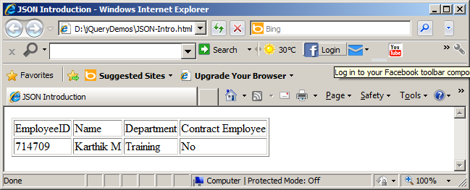

Figure 13 JSON-Intro.html in browser

## 3.2: Working with JSON Object and Array

Create a webpage to illustrate the usage of JSON object and Array types

Solution:

**Step 1:** Open any text editor like notepad and type the following code and save it with .html extension

**Step 2:** Output will appear as shown in the following figure

<html>

<head>

<title>JSON Array and Object</title>

<script type="text/javascript">

var jsonObject = {"EmployeeID":"714709","Name":"Karthik",

"office":{

"company":"iGATE Patni",

"city":"Bangalore"

},

"Hobbies":["Programming","Music"]

}

var parsedJson = eval(jsonObject);

var result = "Name : "+parsedJson.Name+"<br/>Company : "+parsedJson.office.company+"<br/>Hobby : "+parsedJson.Hobbies[0];

document.write(result);

</script>

</head>

<body>

</body>

</html>

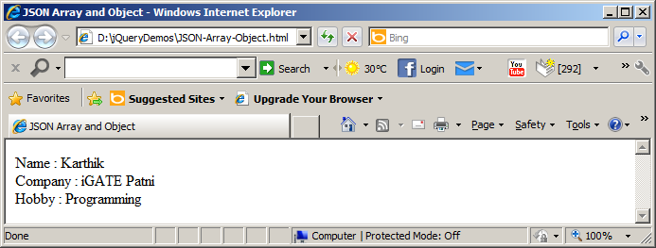

Figure 14 JSON-Array-Object.html in browser

## 3.3: Using JSON object in jQuery

Create a jQuery webpage to format a div tag with some list of css properties in JSON format.

Solution:

**Step 1:** Open any text editor like notepad and type the following code and save it with .html extension

<html>

<head>

<title>Using JSON in jQuery</title>

<script type="text/javascript" src="Scripts/jquery-1.6.4.min.js"></script>

<script type="text/javascript">

$(document).ready(function()

{

var collection = $('#targetDiv');

//using JSON to avoid Method chaining

collection.css({"border":"5px solid green",

"padding":"10px",

"background-color":"blue",

"color":"white",

"font-size":"24pt",

"font-family":"verdana",

"font-weight":"bold",

"text-transform":"uppercase"

});

});

</script>

</head>

<body>

<div id="targetDiv">

<p>Using JSON in jQuery</p>

</div>

</body>

</html>

**Step 2:** Output will appear as shown in the following figure

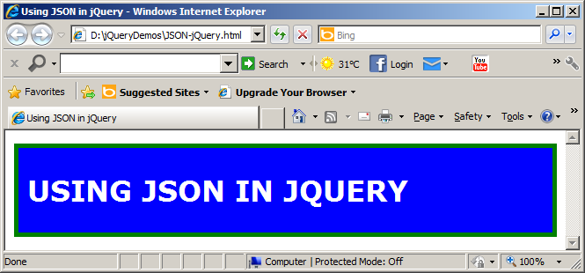

Figure 15 JSON-jQuery.html in browser

1. Interacting with DOM

|  |  |
| --- | --- |
| **Goals** | * At the end of this lab session, you will be able to * Perform DOM Manipulations * Interact with DOM elements using jQuery |
| **Time** | 30 minutes |

## 4.1: Iterate Nodes using jQuery

Create a jQuery webpage to iterate through the DOM tree using jQuery

Solution:

**Step 1:** Open any text editor like notepad and type the following code and save it with .html extension

<html>

<head>

<title>DOM Iterations</title>

<style type="text/css">

.main{background-color:blue;color:white}

.company{background-color:yellow;color:black}

.sales{background-color:crimson;color:white}

.hr{background-color:green;color:white}

.training{background-color:brown;color:white}

</style>

<script type="text/javascript" src="Scripts/jquery-1.6.4.min.js"></script>

<script type="text/javascript">

$(document).ready(function()

{

var main = $("#mainDiv").children();

var company = $("#company").children();

$("#targetDiv").append("<h2> MainDiv has "+main.length+" children</h2>");

$("#targetDiv").append("<h2> Company has "+company.length+" children(s)</h2>");

var result="";

$(company).each(function(index)

{

result+=index+" "+$(this).text()+"<br/>";

});

$("#targetDiv").append("<h2>"+result+"</h2>");

});

</script>

</head>

<body>

<div id="mainDiv" class="main">Main

<div id="company" class="company">iGATE Patni

<div id="sales" class="sales">Sales Team</div>

<div id="hr" class="hr">HR Team</div>

<div id="training" class="training">Training</div>

</div>

</div>

<div id="targetDiv"></div>

</body>

</html>

**Step 2:** Output will appear as shown in the following figure

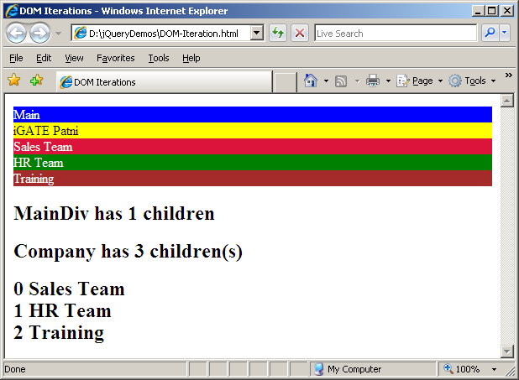

Figure 16 DOM-Iteration.html in browser

## 4.2: Sort list items using jQuery

Create a jQuery webpage to sort list items and attach style (change the list item bullet to icon) to the sorted list using jQuery

Solution:

**Step 1:** Open any text editor like notepad and type the following code and save it with .html extension

<html>

<head>

<title>Sorting list items using jQuery</title>

<style type="text/css">

.java{

list-style-image:url('images/java.png');

}

</style>

<script type="text/javascript" src="Scripts/jquery-1.6.4.min.js"></script>

<script type="text/javascript">

$(document).ready(function()

{

if(confirm('Are you sure to sort these JEE technologies?'))

{

//Applying JavaScript built-in sort() function

var sortedjava = $('.ilearn_menu li').sort(function(o, n) {

return $(o).text() < $(n).text() ? -1 : 1;

});

//Applying Style

sortedjava.addClass('java');

//Removing Node

$('#sourceDiv').remove();

//Appending the sorted data in targetDiv

$('#targetDiv').append(sortedjava);

}

});

</script>

</head>

<body>

<div id="sourceDiv">

<ul class="ilearn_menu">

<li>Struts</li>

<li>JSP</li>

<li>Servlets</li>

<li>EJB</li>

<li>RMI</li>

</ul>

</div>

<div id="targetDiv"></div>

</body>

</html>

**Step 2:** Output will appear as shown in the following figure

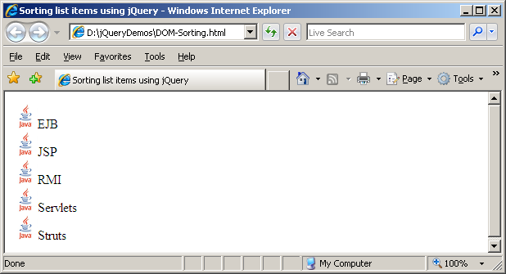

Figure 17 DOM-Sorting.html in browser

**Note**: Save this image  under D:\jQueryDemos\images

## Stretched Assignments

Assignment-1: Sort the same list listed above in descending order

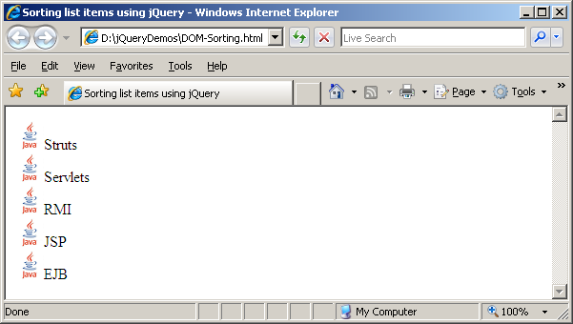

Figure 18 Sorting list items in descending order

## TODO Assignments

Assignment-1: Create an unordered list like given below detach mainframe technologies list from last and add it before dotnet technologies

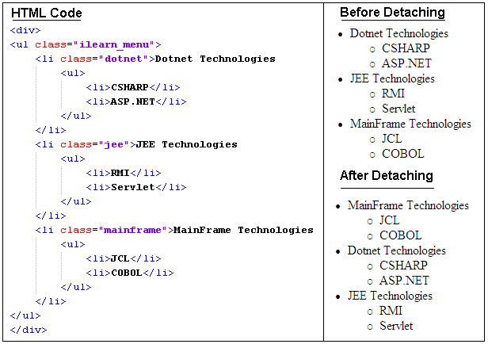

Figure 19 DOM Assignment

1. Handling Events & Animations in jQuery

|  |  |
| --- | --- |
| **Goals** | * At the end of this lab session, you will be able to * Handle events in jQuery * Perform animations using jQuery |
| **Time** | 90 minutes |

## 5.1: Adding and Removing Style at runtime using Click Event

Create a jQuery webpage to add and remove style from div tag when a button is clicked

Solution:

**Step 1:** Open any text editor like notepad and type the following code and save it with .html extension

<html>

<head>

<title>Click Event</title>

<style type="text/css">

.custom{background-color:blue;color:white;font-size:24pt;border:10px solid green}

</style>

<script type="text/javascript" src="Scripts/jquery-1.6.4.min.js"></script>

<script type="text/javascript">

$(document).ready(function()

{

$('#btnAddRemove').click(function(){

$('#targetDiv').toggleClass('custom');

});

});

</script>

</head>

<body>

<p>

<input type="button" id="btnAddRemove" value="Add Style / Remove Style"/>

</p>

<div id="targetDiv">

Div tag formatted with CSS Style

</div>

</body>

</html>

**Step 2:** Output will appear as shown in the following figure

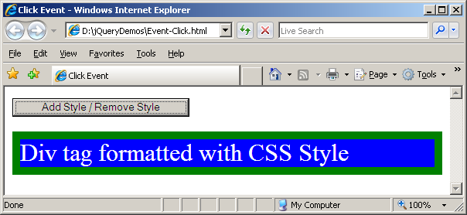

Figure 20 Event-Click.html in browser

## 5.2: Preventing Cut-Copy-Paste in textbox

Create a jQuery webpage which prevent Cut, Copy, Paste operations in a textbox

Solution:

**Step 1:** Open any text editor like notepad and type the following code and save it with .html extension

<html>

<head>

<title>Preventing Cut-Copy-Paste</title>

<script type="text/javascript" src="Scripts/jquery-1.6.4.min.js"></script>

<script type="text/javascript">

$(document).ready(function()

{

$('input[id="txtSample"]').bind('cut copy paste', function(e) {

e.preventDefault();

alert('You cannot ' + e.type + ' text!');

});

});

</script>

</head>

<body>

<div>

Special Textbox : <input id="txtSample" type="text"/>

</div>

</body>

</html>

**Step 2:** Output will appear as shown in the following figure

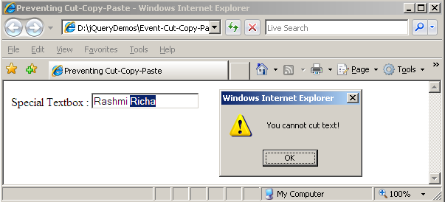

Figure 21Event-Cut-Copy-Paste.html in browser

## 5.3: Identifying mouse button

Create a jQuery webpage and identify which mouse button is pressed in the specified target

Solution:

**Step 1:** Open any text editor like notepad and type the following code and save it with .html extension

<html>

<head>

<title>Mouse Button identification</title>

<style type="text/css">

.custom{background-color:blue;color:white;font-size:24pt;border:10px solid green}

</style>

<script type="text/javascript" src="Scripts/jquery-1.6.4.min.js"></script>

<script type="text/javascript">

$(document).ready(function()

{

$('#targetDiv').mousedown(function(event)

{

switch (event.which)

{

case 1:

alert('Left mouse button pressed');

break;

case 2:

alert('Middle mouse button pressed');

break;

case 3:

alert('Right mouse button pressed');

break;

default:

alert('You have a strange mouse');

}

});

});

</script>

</head>

<body>

<div id="targetDiv" class="custom">

Click here to know which mouse button is pressed

</div>

</body>

</html>

**Step 2:** Output will appear as shown in the following figure

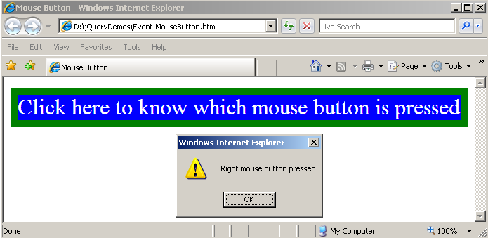

Figure 22 Event-MouseButton.html in browser

## 5.4: Limiting number of characters in textarea

Create a jQuery webpage which limits the number of character in textarea

Solution:

**Step 1:** Open any text editor like notepad and type the following code and save it with .html extension

<html>

<head>

<title>Limiting number of characters in textarea</title>

<style type="text/css">

.custom{background-color:red}

</style>

<script type="text/javascript" src="Scripts/jquery-1.6.4.min.js"></script>

<script type="text/javascript">

$(document).ready(function()

{

var limit = 25;

var $tb = $('#comments');

$tb.keyup(function(e) {

var len = $(this).val().length;

if (len > limit)

this.value = this.value.substring(0, limit);

else

$('#charLeft').text(limit - len + " characters left");

});

});

</script>

</head>

<body>

<div>

<h2>Type into this textbox which accepts 25 characters overall</h2>

<textarea id="comments" rows="5" cols="40"></textarea>

<br/>

<span id="charLeft"></span>

</div>

</body>

</html>

**Step 2:** Output will appear as shown in the following figure

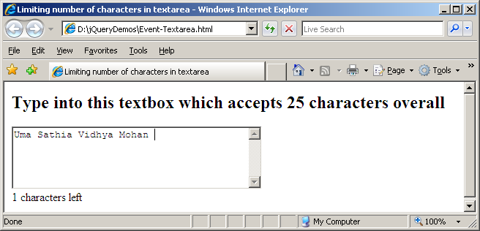

Figure 23 Event-Text area. html

## 5.5: Check/Uncheck all checkboxes at once

Create a jQuery webpage which Check/Uncheck all checkboxes at once

Solution:

**Step 1:** Open any text editor like notepad and type the following code and save it with .html extension

<html>

<head>

<title>Check/Uncheck all checkboxes at once</title>

<script type="text/javascript" src="Scripts/jquery-1.6.4.min.js"></script>

<script type="text/javascript">

$(document).ready(function()

{

var $chkBox = $("input:checkbox[id$=chkAll]");

var $tblChkBox = $("table.chk input:checkbox");

$chkBox.click(function() {

$tblChkBox.attr('checked', $chkBox.is(':checked'));

});

// Unchecks chkAll when a checked CheckBox in cbList is unchecked

$tblChkBox.click(function(e) {

if (!$(this)[0].checked) {

$chkBox.attr("checked", false);

}

});

});

</script></head>

<body>

<div class="smallDiv">

<h2>Check/Uncheck all checkboxes at once</h2><br />

<span title="Click here to check/uncheck all checkboxes at once">

<input id="chkAll" type="checkbox" name="chkAll" /><label>Do All</label>

</span>

<br /><hr />

<table id="cbList" class="chk" border="0">

<tr>

<td><input id="cbList0" type="checkbox" name="cbList0" /><label>Option One</label></td>

</tr> <tr>

<td><input id="cbList1" type="checkbox" name="cbList1" /><label>Option Two</label></td> </tr>

<tr>

<td><input id="cbList2" type="checkbox" name="cbList2" /><label>Option Three</label></td></tr>

<tr>

<td><input id="cbList3" type="checkbox" name="cbList3" /><label>Option Four</label></td> </tr>

</table>

</div>

</body>

</html>

**Step 2:** Output will appear as shown in the following figure

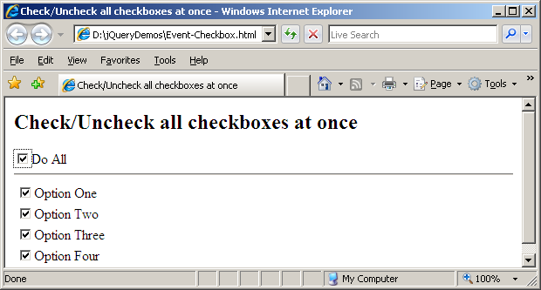

Figure 24 Event-Checkbox.html in browser

## 5.6: Event Triggering

Create a jQuery webpage which illustrates Event triggering (Invoke the second button Click event when the first button is clicked)

Solution:

**Step 1:** Open any text editor like notepad and type the following code and save it with .html extension

<html>

<head>

<title>Event Trigger</title>

<script type="text/javascript" src="Scripts/jquery-1.6.4.min.js"></script>

<script type="text/javascript">

$(document).ready(function()

{

$('#btnSecond').click(function(){

alert('Second Button Clicked');

});

$('#btnFirst').click(function(){

$('#btnSecond').trigger("click");

});

});

</script>

</head>

<body><div>

<input id="btnFirst" type="button" value="First" />

<input id="btnSecond" type="button" value="Second" />

</div></body>

</html>

**Step 2:** Output will appear as shown in the following figure

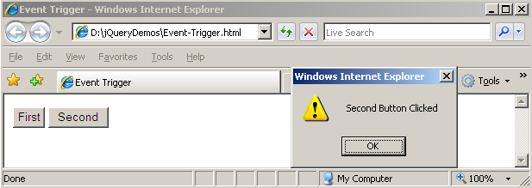

Figure 25 Event-Trigger.html in browser

## 5.7: Animating List as tree view

Create a jQuery webpage to animate list items like a tree view

Solution:

**Step 1:** Open any text editor like notepad and type the following code and save it with .html extension

**Step 2:** Output will appear as shown in the following figure

<html>

<head>

<title>Animating List</title>

<script type="text/javascript" src="Scripts/jquery-1.6.4.min.js"></script>

<script type="text/javascript">

$(document).ready(function()

{

$('li:has(ul)').click(function(event){

if (this == event.target) {

$(this).css("list-style-image",

(!$(this).children().is(":hidden")) ?"url('images/plus.gif')" : "url('images/minus.gif')");

$(this).children().toggle('slow');

}

return false;

}).css({"cursor":"pointer","list-style-image":"url('images/plus.gif')"}).children().hide();

$("li:not(:has(ul))").css({"cursor":"default","list-style-image":"none"});

});

</script>

</head>

<body>

<div>

<ul class="ilearn_menu">

<li>Dotnet Technologies

<ul> <li>CSHARP</li> <li>ASP.NET</li> </ul>

</li>

<li>JEE Technologies

<ul> <li>RMI</li> <li>Servlet</li> </ul>

</li>

<li>Mainframe Technologies

<ul> <li>JCL</li> <li>COBOL</li> </ul>

</li>

</ul>

</div>

</body>

</html>

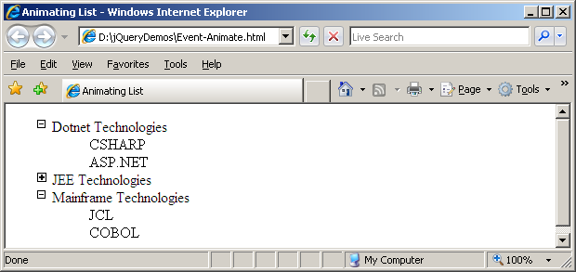

Figure 26 Event-Animate.html in browser

**Note**: Save this image (plus.gif) and (minus.gif) under D:\jQueryDemos\images

## TODO Assignments

Assignment-1: Create a jQuery webpage to Change the URL of a Hyperlink from google.com to bing.com and disable the button once it is clicked

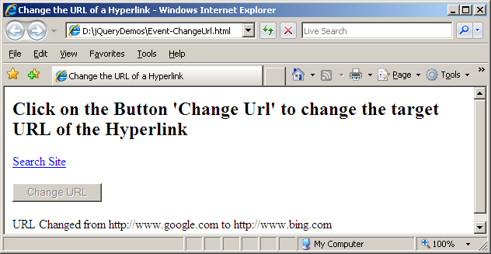

Figure 27 Assignment Output

1. Working with Ajax

|  |  |
| --- | --- |
| **Goals** | * At the end of this lab session, you will be able to * Making GET / POST Requests * Using jQuery Ajax functions |
| **Time** | 90 minutes |
| exclamation Patni domain users change the server name to **igtechntrndb01** to **arltrgsrv** | |

## 6.1: Using jQuery load() function

Create a jQuery webpage to print the multiplication table of the given number using jQuery load() function

Solution:

**Step 1:** Open any text editor like notepad and type the following code and save it with .html extension

<html>

<head>

<title>Using Load Function</title>

<script type="text/javascript" src="Scripts/jquery-1.4.1.js"></script>

<script type="text/javascript">

$(document).ready(function()

{

$("#btnLoad").click(function(){

var regex=/^[0-9]+$/;

var number = $("#txtNumber").val();

if(regex.test(number))

{

$("#target").load('http://igtechntrndb01/jQueryService/Multiplication.aspx',{num:number});

}

else

{

$("#txtNumber").val("");

$("#txtNumber").focus();

$("#target").html("Invalid Number");

}

});

});

</script>

</head>

<body>

<h2>Print Multiplication table of the given number</h2>

<div>

<label>Number : </label><input type="text" id="txtNumber" maxlength="9"/><br/><br/>

<input id="btnLoad" type="button" value="Print Multiplication Table"/>

</div>

<br/>

<div id="target"></div>

</body>

</html>

**Step 2:** Output will appear as shown in the following figure

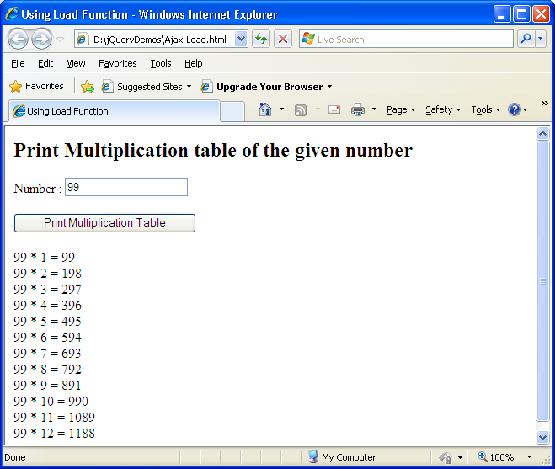

Figure 28 Ajax-Load.html in browser

## 6.2: Using jQuery post() function

Create a jQuery webpage to add two numbers by consuming web service using jQuery post() function

Solution:

**Step 1:** Open any text editor like notepad and type the following code and save it with .html extension

<html>

<head>

<title>Using Post Function</title>

<script type="text/javascript" src="Scripts/jquery-1.4.1.js"></script>

<script type="text/javascript">

$(document).ready(function()

{

$('#txtResult').attr("readonly", "readonly");

$('#btnAddNumber').click(function(){

var firstNumber = $("#txtFirstNumber").val();

var secondNumber = $("#txtSecondNumber").val();

var data = {'firstNumber':firstNumber,'secondNumber':secondNumber};

$.post('http://igtechntrndb01/jQueryService/Calculation.asmx/AddNumbers',data,function(result){

$('#txtResult').val($(result).find('int').text());

},"xml");

});

});

</script>

</head>

<body> <h2>Adding Numbers using WebService</h2>

<table>

<tr><td align="right"><label>First Number :</label></td>

<td><input id="txtFirstNumber" type="text" value="0" /></td></tr>

<tr><td align="right"><label>Second Number :</label></td>

<td><input id="txtSecondNumber" type="text" value="0"/></td></tr>

<tr>

<td align="right"><label>Result :</label></td>

<td><input id="txtResult" type="text" value="0"/></td>

</tr>

<tr>

<td align="center" colspan="2"><input id="btnAddNumber" type="button" value="Add Numbers" /></td>

</tr>

</body>

</html>

**Step 2:** Output will appear as shown in the following figure

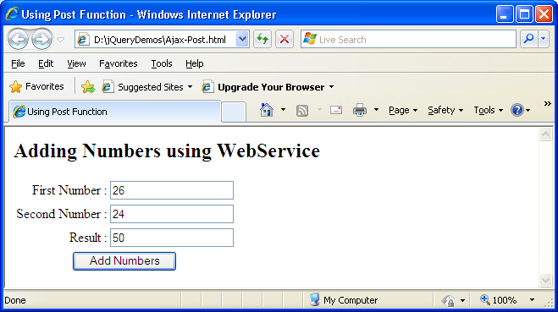

Figure 29 Ajax-post.html in browser

## 6.3: Using jQuery ajax() function

Create a jQuery webpage to retrieve employee details by consuming web service using jQuery ajax() function

Solution:

**Step 1:** Open any text editor like notepad and type the following code and save it with .html extension

<html>

<head>

<title>Using Ajax Function</title>

<script type="text/javascript" src="Scripts/jquery-1.4.1.js"></script>

<script type="text/javascript">

$(document).ready(function()

{

$('#btnLoad').click(function(){

$.ajax({

type: "POST",

url: "http://igtechntrndb01/jQueryService/employeeservice.asmx/GetAllEmployees",

dataType: "xml",

success: function(response){

var results="<table border='1'><thead><th>ID</th><th>Name</th></thead>";

$(response).find('Employee').each(function(){

results+="<tr><td>"+$(this).find('ID').text()+"</td>"

+"<td>"+ $(this).find('Name').text()+"</td></tr>";

});

results+="</table>";

$('#targetDiv').html(results);

},

error: function(response, status, error) {

$("#target").html(response.statusText);

}

});

});

});

</script>

</head>

<body><h2>Using jQuery ajax() function</h2>

<div><input id="btnLoad" type="button" value="Load Employees"/></div>

<br/><div id="targetDiv"></div>

</body>

</html>

**Step 2:** Output will appear as shown in the following figure

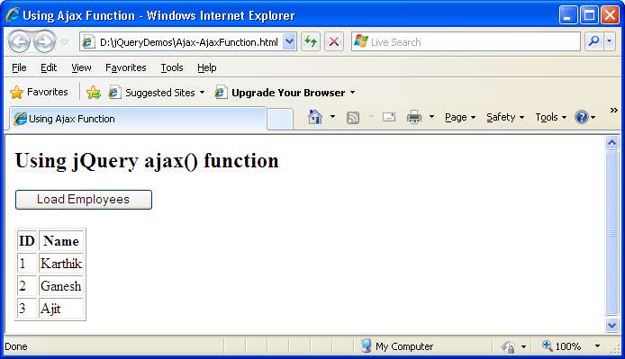

Figure 30 Ajax-AjaxFunction.html in browser

## 6.4: Insert record using RESTful Service(POST verb)

Create a jQuery webpage to insert record using RESTful service

Solution:

**Step 1:** Open any text editor like notepad and type the following code and save it with .html extension

<html>

<head>

<title>Ajax RESTful-POST</title>

<script type="text/javascript" src="Scripts/jquery-1.4.1.js"></script>

<script type="text/javascript">

$(document).ready(function()

{

$('#btnInsert').click(function(){

var guestID = $('#txtID').val();

var guestName = $('#txtName').val();

var phoneNumber = $('#txtPhoneNumber').val();

$.ajax({

type: "POST",

url: "http://igtechntrndb01/jQueryService/GuestService.svc/guests",

contentType: "application/json; charset=utf-8",

data: "{\"GuestID\":\"" + guestID + "\", \"GuestName\":\"" + guestName + "\", \"PhoneNumber\":\"" + phoneNumber + "\"}",

dataType: "json",

success: function(response){

var guestAdded = eval(response);

if(guestAdded)

alert('Details Inserted');

else

alert('Error in insertion');

},

error: function(response, status, error) {

alert(response.statusText);

}

});

});

});

</script>

</head>

<body>

<h2>Ajax RESTful-POST(Guest Entry)</h2>

<table>

<tr>

<td align="right"><label>ID : </label></td>

<td><input type="text" id="txtID"/></td>

</tr>

<tr>

<td align="right"><label>Name : </label></td>

<td><input type="text" id="txtName"/></td>

</tr>

<tr>

<td align="right"><label>PhoneNumber : </label></td>

<td><input type="text" id="txtPhoneNumber"/></td>

</tr>

<tr>

<td><input type="text" id="txtPhoneNumber"/></td>

</tr>

</table>

<input id="btnInsert" type="button" value="Insert"/>

</body>

</html>

**Step 2:** Output will appear as shown in the following figure

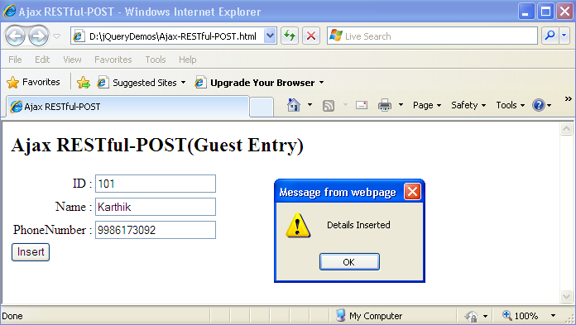

Figure 31 Ajax-RESTful-POST.html in browser

## 6.5: Retrieve record(s) using RESTful Service (GET verb)

Create a jQuery webpage to retrieve record using RESTful service

Solution:

**Step 1:** Open any text editor like notepad and type the following code and save it with .html extension

<html>

<head>

<title>Ajax RESTful-GET</title>

<script type="text/javascript" src="Scripts/jquery-1.4.1.js"></script>

<script type="text/javascript">

$(document).ready(function()

{

$("#loading").hide();

$("#loading")

.ajaxStart(function(){

$(this).show();

})

.ajaxStop(function(){

$(this).hide();

});

$('#btnLoad').click(function(){

var results = "";

$.ajax({

type: "GET",

cache: false,

url: "http://igtechntrndb01/jQueryService/GuestService.svc/guests",

contentType: "application/json; charset=utf-8",

dataType: "json",

success: function(response){

var guests = eval(response);

$.each(guests, function(index, guest) {

results+=guest.GuestID+" "+guest.GuestName+" "+guest.PhoneNumber+"<br/>";

});

$('#targetDiv').html(results);

},

error: function(response, status, error) {

alert(response.statusText);

}

});

});

});

</script>

</head>

<body>

<h2>Ajax RESTful-GET(Guest Entry)</h2>

<div>

<input id="btnLoad" type="button" value="Load Details"/>

</div>

<div id="loading"><p><img src="images\spinner.gif"/>Loading...</p></div>

<br/>

<div id="targetDiv"></div>

</body>

</html>

**Step 2:** Output will appear as shown in the following figure

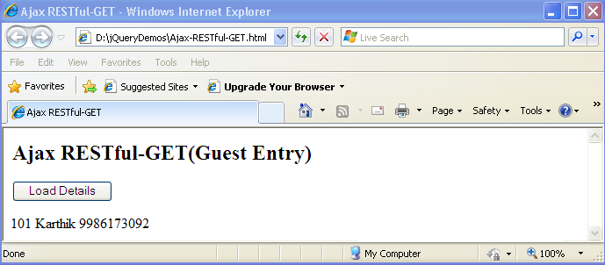

Figure 32 Ajax-RESTful-GET.html

## 6.5: Delete record using RESTful Service (DELETE verb)

Create a jQuery webpage to delete record using RESTful service

Solution:

**Step 1:** Open any text editor like notepad and type the following code and save it with .html extension

<html>

<head>

<title>Ajax RESTful-DELETE</title>

<script type="text/javascript" src="Scripts/jquery-1.4.1.js"></script>

<script type="text/javascript">

$(document).ready(function()

{

$('#btnDelete').click(function(){

var guestID = $('#txtID').val();

$.ajax({

type: "DELETE",

url: "http://igtechntrndb01/jQueryService/GuestService.svc/guest/"+guestID,

contentType: "application/json; charset=utf-8",

success: function(response){

var guestDeleted = eval(response);

if(guestDeleted)

alert('Details Deleted');

else

alert('Error in Deletion');

},

error: function(response, status, error) {

alert(response.statusText);

}

});

});

});

</script>

</head>

<body>

<h2>Ajax RESTful-DELETE(Guest Entry)</h2>

<table>

<tr>

<td align="right"><label>ID : </label></td>

<td><input type="text" id="txtID"/></td>

</tr>

</table>

<div>

<input id="btnDelete" type="button" value="Delete"/>

</div>

</body>

</html>

**Step 2:** Output will appear as shown in the following figure

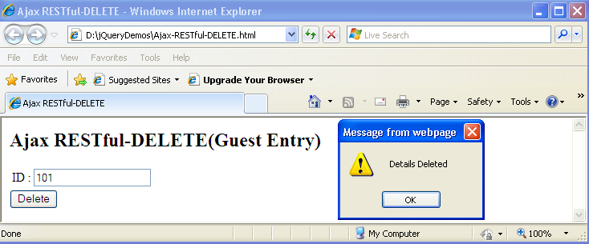

Figure 33 Ajax-RESTful-DELETE.html in browser

1. Working with Plug-ins

|  |  |
| --- | --- |
| **Goals** | * At the end of this lab session, you will be able to * Work with jQuery-UI Plugin * Create function Plugin * Create method Plugin |
| **Time** | 90 minutes |

## 7.1: Using jQuery-UI

Create a jQuery webpage to use buttonset and datepicker from jQuery-UI

Solution:

**Step 1:** Open jQuery UI download page:http://jqueryui.com/download

**Step 2:** Choose the components and theme for custom download

**Step 3:** Choose the components and theme for custom download unzip the contents with the folder structure given below

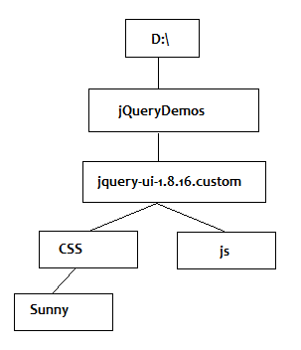

**Step 4:** Open any text editor like notepad and type the following code and save it with .html extension

<!DOCTYPE html PUBLIC "-//W3C//DTD XHTML 1.0 Strict//EN" "http://www.w3.org/TR/xhtml1/DTD/xhtml1-strict.dtd">

<html xmlns="http://www.w3.org/1999/xhtml">

<head>

<meta http-equiv="Content-Type" content="text/html; charset=UTF-8" />

<title>jQuery UI</title>

<link type="text/css" href="jquery-ui-1.8.16.custom/css/sunny/jquery-ui-1.8.16.custom.css" rel="stylesheet" />

<script src="jquery-ui-1.8.16.custom/js/jquery-1.6.2.min.js"></script>

<script src="jquery-ui-1.8.16.custom/js/jquery-ui-1.8.16.custom.min.js"></script>

<script type="text/javascript">

$(document).ready(function(){

$( "#radio" ).buttonset();

$('#datepicker').datepicker({ changeMonth: true, changeYear: true});

});

</script>

</head>

<body>

<h2>Favorite Game</h2>

<div id="radio">

<input type="radio" id="radio1" name="radio" />

<label for="radio1">Cricket</label>

<input type="radio" id="radio2" name="radio" />

<label for="radio2">Tennis</label>

<input type="radio" id="radio3" name="radio" />

<label for="radio3">Chess</label>

</div>

<br/>

<label>Date of Birth : </label>

<input type="text" id="datepicker">

</body>

</html>

**Step 2:** Output will appear as shown in the following figure

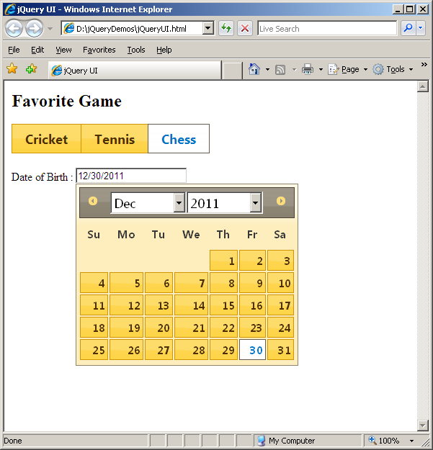

Figure 34 jQueryUI.html in browser

## TODO Assignments

**Assignment-1**: Create a jQuery webpage and use accordion from jQuery UI

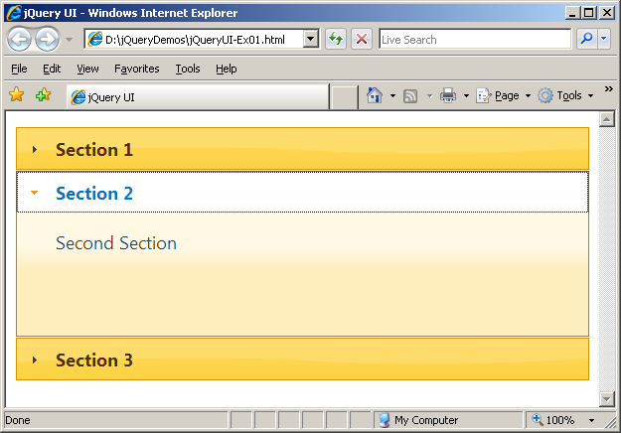

Figure 35 jQueryUI-Ex01.html in browser

**Assignment-2**: Create a jQuery webpage and use Datatable plugin to display the result like given below

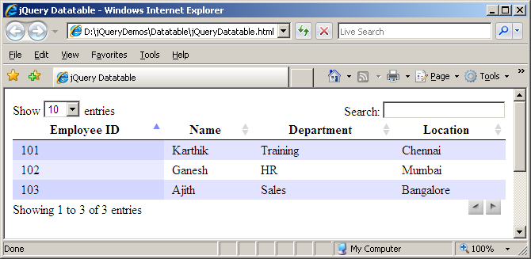

Figure 36 jQueryDatatable.html in browser

## 7.2: Creating Function Plugin

Create a jQuery webpage which use custom function plugin

Solution:

**Step 1:** Open Editor and type the following and save it as **jquery.isNumber.js**

(function($) {

$.isNumber = function(value) {

var result = false;

var regex=/^[0-9]+$/;

if(regex.test(value))

{

result = true;

}

return result;

};

})(jQuery);

**Step 2:** Open Editor and type the following and save it as **Plugin-isNumber.html**

<html>

<head>

<title>jQuery Plugin</title>

<script type="text/javascript" src="Scripts\jquery-1.4.1.js"></script>

<script type="text/javascript" src="Scripts\jquery.isNumber.js"></script>

<script type="text/javascript">

$(document).ready(function() {

var result = $.isNumber("A");

if(result)

alert('It is a Number');

else

alert('It is a Not Number');

});

</script>

</head>

<body>

</body>

</html>

**Step 3:** Output will appear as shown in the following figure

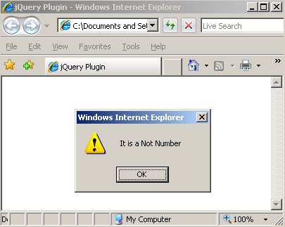

Figure 37 Plugin-isNumber.html in browser

## 7.2: Creating Method Plugin

Create a jQuery webpage which use custom method plugin

Solution:

**Step 1:** Open Editor and type the following and save it as **jquery.customTooltip.js**

(function($) {

$.fn.customTooltip = function(message) {

return this.each(function() {

this.title=message;

});

}

})(jQuery);

**Step 2:** Open Editor and type the following and save it as **Plugin-isNumber.html**

<html>

<head>

<title>jQuery Plugin</title>

<script type="text/javascript" src="Scripts\jquery-1.4.1.js"></script>

<script type="text/javascript" src="Scripts\jquery.isNumber.js"></script>

<script type="text/javascript">

$(document).ready(function() {

var result = $.isNumber("A");

if(result)

alert('It is a Number');

else

alert('It is a Not Number');

});

</script>

**Step 3:** Output will appear as shown in the following figure

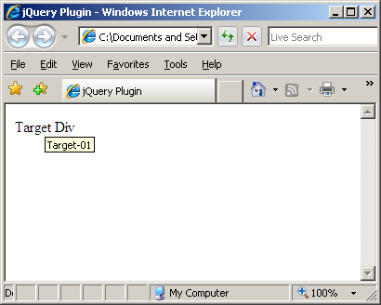

Figure 38 Plugin-customTooltip.html

## 7.3: Creating Method Plugin(Form Validation)

Create a jQuery webpage which use custom method plugin which do form validation i.e. check for the required fields

Solution:

**Step 1:** Open Editor and type the following and save it as **jquery.formCheck.js**

(function($) {

$.fn.formCheck = function(options) {

var defaults = {

errorClass: "error"

};

var option = jQuery.extend(defaults, options);

return this.each(function() {

var form = $(this);

if(!form.is ("form")) return;

form.submit(function() {

var errorFlag = false;

$(":input", this).each(function(index, element) {

e = $(element);

e.removeClass(option.errorClass);

if(e.hasClass("required") && e.val() == '') {

errorFlag = true;

e.addClass(option.errorClass);

}

});

return !errorFlag; //To avoid submitting the Form

});

});

};

})(jQuery);

**Step 2:** Open Editor and type the following and save it as **Plugin-formCheck.html**

<html>

<head>

<title>jQuery Plugin</title>

<style type="text/css">

form { width: 300px; }

.error { border: 1px solid red }

</style>

<script type="text/javascript" src="Scripts\jquery-1.4.1.js"></script>

<script type="text/javascript" src="Scripts\jquery.formCheck.js"></script>

<script type="text/javascript">

$(document).ready(function() {

$(".formToCheck").formCheck();

});

</script>

</head>

<body>

<form class="formToCheck" id="formToCheck" method="get" action="#">

<fieldset>

<legend>Form Validation</legend>

<p>

<label for="txtEmployeeID">*EmployeeID : </label>

<input id="txtEmployeeID" class="required" />

</p>

<p>

<label for="txtEmployeeName">*Employee Name : </label>

<input id="txtEmployeeName" class="required" />

</p>

<p>

<input class="submit" type="submit" value="Submit"/>

</p>

</fieldset>

</form>

</body>

</html>

**Step 3:** Output will appear as shown in the following figure

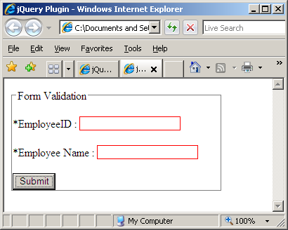

Figure 39 Plugin-Form Check.html in browser

## <<Streched Assignment>>

Extend the **jquery.formCheck.js** to validate Email Address and Pincode Number in the Form

Appendices

## Appendix A: Coding Best Practices

Assign selectors to local variables instead of overusing it

$('#button').click(function()

{

$('#label').method();

$('#label').method2();

}

$('#button').click(function()

{

var $label = $('#label');

$label.method();

$label.method2();

}

Best way is using chaining

$('#button').click(function()

{

$('#label').method().method2();

}

All variables that are used to store/cache jQuery objects should have a name prefixed with a ‘$’.

var $MyTable = $("#MyTable");

Manipulation of the Document Object Model (DOM) can be costly and inefficient, regardless of whether it is undertaken through jQuery or JavaScript.

var $myList = $("#myList");

for (i=0; i<1000; i++){

$myList.append("This is list item " + i);

}

This code adds 1000 lines to an HTML list. This is done with 1000 successive calls to the .append() method, and hence, 1000 manipulations to the DOM. Code needs to be re-written as given below

var $myList = $("#myList");

var li = "";

for (i=0; i<1000; i++){

li += "<li>This is list item " + i + "</li>";

}

$myList.append(li);

Declare the styles in a class within a CSS StyleSheet file and use .addClass(), .removeClass() or .toggleClass() upon your selecteded object(s). For example, avoid this type of declaration:

$("#MyTR").css({

"background-color":"gray"

});

Use instead:

$("#MyTR").addClass("HighlightRow");

/*In CSS File:*/

.HighlightRow

{

background-color:gray;

}

Use #ID selector wherever possible. It is the fastest. Ensure slower selectors are optimized for performance – Combine them with faster selectors where possible.

//Inefficient: scans DOM for all elements with oddrows class

$(".oddRows");

//More efficient: Searches only <tr> with oddrows class

$("tr.oddRows");

//More efficient: searches descendents of #MyTable

$("#MyTable tr.oddRows");

//Best: searches immediate children

$("#MyTable>tbody>tr.oddRows");

Don't use bare class selectors, like given below, this will end up looking at every single element to see if it has a class of "button".

$('.button').click(function() { /* do something */ });

//Instead use this

$('span.button').click(function() { /* do something */ });

Return 'false' to prevent default behavior

//use this

$('popup').click(function(){

// Launch popup code

return false;

});

//instead of this

$('popup').click(function(){

// Launch popup code

});

While using $.ajax function for Ajax requests to server, you should avoid using the complete event to process response data. It will fire whether the request was successful or not. Rather than complete, use success.

## Appendix B: Table of Figures

Figure 1: jquery.com 6

Figure 2: jQuery Folder Structure 7

Figure 3: Save contents as an *.html* file 7

Figure 4: HelloWorld.html in a browser 8

Figure 5 Accessing Script from CDN 8

Figure 6 jQueryCDN.html in browser 9

Figure 7 Selectors-TagName.html in browser 11

Figure 8 Selectors-ID.html in browser 12

Figure 9 Selectors-Classname.html in browser 14

Figure 10 Selectors-attributes.html in browser 15

Figure 11 Selectors-FormElements.html in browser 17

Figure 12 Assignment output 19

Figure 13 JSON-Intro.html in browser 21

Figure 14 JSON-Array-Object.html in browser 22

Figure 15 JSON-jQuery.html in browser 23

Figure 16 DOM-Iteration.html in browser 25

Figure 17 DOM-Sorting.html in browser 27

Figure 18 Sorting list items in descending order 27

Figure 19 DOM Assignment 28

Figure 20 Event-Click.html in browser 30

Figure 21Event-Cut-Copy-Paste.html in browser 31

Figure 22 Event-MouseButton.html in browser 32

Figure 23 Event-Text area. html 34

Figure 24 Event-Checkbox.html in browser 35

Figure 25 Event-Trigger.html in browser 36

Figure 26 Event-Animate.html in browser 38

Figure 27 Assignment Output 38

Figure 28 Ajax-Load.html in browser 40

Figure 29 Ajax-post.html in browser 42

Figure 30 Ajax-AjaxFunction.html in browser 43

Figure 31 Ajax-RESTful-POST.html in browser 45

Figure 32 Ajax-RESTful-GET.html 47

Figure 33 Ajax-RESTful-DELETE.html in browser 49

Figure 34 jQueryUI.html in browser 52

Figure 35 jQueryUI-Ex01.html in browser 53

Figure 36 jQueryDatatable.html in browser 53

Figure 37 Plugin-isNumber.html in browser 55

Figure 38 Plugin-customTooltip.html 56

Figure 39 Plugin-Form Check.html in browser 59